TECHNICAL UNIVERSITY - SOFIA
FACULTY OF COMPUTER SYSTEMS AND TECHNOLOGIES

BACHELOR THESIS ON TOPIC OF
DEVELOPING WEB SYSTEM USING CONVOLUTIONAL NEURAL NETWORK FOR CLASSIFICATION OF PLANT DISEASES

KIRIL SHIYAN
2026
FACULTY NUMBER 273222008

2026
TABLE OF CONTENTS

Ⅰ. INTRODUCTION 4
Ⅱ. PROBLEM DOMAIN AND LITERATURE REVIEW 6
HISTORIC OVERVIEW OF NEURAL NETWORKS 6
THEORY BEHIND NEURAL NETWORKS 8
GENERAL ARCHITECTURE OF CNN 8
TRANSFER LEARNING 10
PLANT DISEASE DATASETS 12
PLANTVILLAGE 12
PLANTDOC 13
EXISTING PLANT DISEASE CLASSIFICATION MODELS 14
MOHANTY ET AL. [6] 14
SALMAN ET AL. [1] 15
Ⅲ. SYSTEM DESIGN 17
GOALS AND OBJECTIVES 17
WEB MODULE 18
SYSTEM FUNCTIONS 18
SYNTHESIS OF STRUCTURE - FRONTEND 19
SYNTHESIS OF STRUCTURE - BACKEND 21
SYNTHESIS OF STRUCTURE- ENGINE 23
MODEL TRAINING 25
ASSESSMENT OF DATASETS 25
MODEL SELECTION 26
FINE-TUNING STRATEGY 27
SOURCES 28

Ⅰ. INTRODUCTION
Global food security faces mounting pressure from a convergence of interconnected threats. UN’s 2024 World Population Prospects report projects that world's population is expected to reach just under 10 billion people by 2050 [7], demanding an increase in food production of up to 56% [9] . Yet plant diseases and pests already cost the global economy an estimated USD 220 billion annually, accounting for the loss of 10–16% of all crop production with additional 8 to 12% of post-harvest losses [8]. These losses are not static - climate change is actively worsening them. Studies project losses that can reach 50% by 2050 [8]. Rising temperatures shorten pathogen incubation periods, elevated carbon dioxide levels enhances the severity of diseases such as powdery mildew and wheat head blight, and increased humidity promotes fungal spore germination and infection rates [10]. As a result, pathogens are expanding into regions previously free of disease, and any potential yield gains over the next five decades are projected to be offset by climate-mediated increases in disease pressure [10]. The situation is further aggravated by globalization and international trade, which accelerate the movement of pathogens across continents, exposing crops to diseases against which they have no evolved resistance[10].
Traditional approaches to plant disease management, such as manual inspection by agronomists, chemical fungicides, and disease-resistant cultivars, are increasingly inadequate. Manual diagnosis is slow, costly, labor-intensive, and highly dependent on the expertise of the individual [6]. Chemical controls have reached a plateau of effectiveness as pathogens develop resistance, and their continued use raises serious concerns for soil health, biodiversity, and human health [10]. What is urgently needed, therefore, is a scalable, accurate, and cost-effective system capable of detecting plant disease early, before visible symptoms become severe and before large portions of a crop are lost.
Recent advances in deep learning, particularly Convolutional Neural Networks (CNNs), have opened a promising path toward automated, image-based plant disease recognition [10]. CNNs are capable of learning complex visual features directly from leaf images without the need for manual feature engineering, and when combined with transfer learning from large pretrained models, they can achieve high classification accuracy even on relatively small domain-specific datasets. Studies have demonstrated that CNN-based models trained on the PlantVillage dataset, a publicly available collection of over 54,000 annotated plant leaf images spanning 14 crop species and 26 diseases [11], can accurately identify plant diseases, with some architectures achieving accuracies above 99% on theoretical data [11]. Among these, EfficientNet has emerged as a particularly strong candidate, offering state-of-the-art accuracy with significantly lower computational cost than comparable architectures [4], making it well-suited for deployment in resource-constrained agricultural settings.
The goal of this work is to develop and evaluate a CNN-based plant disease recognition system using transfer learning with EfficientNet using PlantVillage dataset for training and PlantDoc for validation. By enabling rapid, automated, and accurate identification of plant diseases from leaf photographs, such a system could serve as a practical tool for early intervention by helping farmers, agronomists, and agricultural organizations respond to outbreaks before they escalate, reduce reliance on broad-spectrum chemical treatments, and contribute to more resilient and sustainable food production in the face of a changing climate. This work aims to produce end-to-end web system that enables easy and free access to disease classification model.

Ⅱ. PROBLEM DOMAIN AND LITERATURE REVIEW

HISTORIC OVERVIEW OF NEURAL NETWORKS
The origins of artificial neural networks can be traced back to the mid-twentieth century, when researchers first attempted to model the computational behaviour of biological neurons mathematically. The foundational concept was introduced by McCulloch and Pitts [12], who proposed a simplified mathematical model of a neuron as a binary threshold unit - the first formal description of a computational element inspired by the human brain. This was followed by Rosenblatt's Perceptron [13], a single-layer learning algorithm capable of binary classification, which demonstrated for the first time that a machine could learn from data by adjusting its weights through experience. Despite initial enthusiasm, the limitations of single-layer architectures were formally exposed by Minsky and Papert [14], who proved that the Perceptron could not solve non-linearly separable problems such as the XOR function, triggering what became known as the first "AI winter" - a prolonged period of reduced interest and funding in neural network research.
The field was revitalized in 1986 when Rumelhart, Hinton, and Williams published their landmark work on the backpropagation algorithm, which provided an efficient method for training multi-layer networks by propagating error gradients backwards through the network. This enabled, for the first time, the training of deep architectures with hidden layers by laying the theoretical groundwork for all modern neural networks. Building directly on this work, LeCun et al. [16] applied backpropagation to train the first convolutional neural network at AT&T Bell Labs, producing a model capable of recognizing handwritten zip codes from the US Postal Service. His network introduced the key principle of local receptive fields and shared weights, allowing the model to detect spatial patterns regardless of their position in the image. This was achieved by utilizing a novel layers that applied mathematical operation of convolution to input matrix (image in this case). The architecture was refined over the following decade, culminating in LeNet-5 [15], a seven-layer CNN comprising convolutional layers, average pooling layers, and fully connected layers, which achieved 99.05% accuracy on the MNIST handwritten digit benchmark and formally established the architectural template that modern CNNs still follow today.
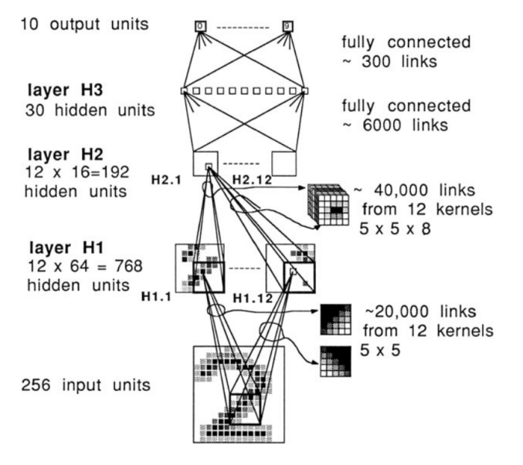
Figure 1.1 - First CNN developed by LeCun et al. [16]
Despite these achievements, CNNs remained computationally impractical for large-scale problems throughout the 1990s and early 2000s, constrained by limited processing power and insufficient training data. The landscape changed dramatically in 2012, when Krizhevsky, Sutskever, and Hinton introduced AlexNet, a deep CNN with five convolutional layers, three fully connected layers, and approximately 60 million parameters trained on 1.2 million images from the ImageNet dataset across 1,000 object categories. AlexNet achieved a top-5 error rate of 17.0% on the ILSVRC-2012 benchmark, outperforming the second-best entry by more than 10 percentage points and triggering a paradigm shift across the entire computer vision community. Critically, AlexNet demonstrated the practical utility of three techniques that are now standard: the ReLU activation function, which accelerated training by avoiding the vanishing gradient problem associated with sigmoid activations; dropout regularization, which reduced overfitting by randomly deactivating neurons during training; and GPU-accelerated computation, which made training on large datasets feasible for the first time.
The years following AlexNet saw rapid architectural innovation. Simonyan and Zisserman [17] introduced VGGNet, which demonstrated that network depth was a critical factor in classification performance - achieving state-of-the-art results on ILSVRC-2014 by stacking up to 19 layers of small 3×3 convolutional filters. VGG16 and VGG19 became widely adopted as transfer learning backbones due to their simplicity and strong representational power.

CNNs have found widespread adoption in domains where processing power is amongst the primary constraints. MobileNetV1 [22] was one of the first architectures explicitly optimized for edge computing environments, introducing depthwise separable convolutions as a drop-in replacement for standard convolutions, dramatically reducing both parameter count and computational cost with only a modest impact on accuracy. Its smallest quantized variant, MobileNetV1 0.25 128, which combines a width multiplier of 0.25 with a reduced input resolution of 128×128 pixels, contains just 0.8 million parameters, a footprint small enough to enable inference without GPU acceleration, even on severely resource-constrained devices such as embedded microcontrollers.

THEORY BEHIND NEURAL NETWORKS

GENERAL ARCHITECTURE OF CNN
While CNNs can utilize a wide variety of layer types in their construction, certain fundamental building blocks appear consistently across the most successful and widely adopted architectures. To understand these core components and their roles, it is necessary to examine them in the context of a concrete example, in particular, aforementioned VGGNet architecture (Fig. 1.2) [17], which, due to its straightforward and systematic design, serves as one of the most commonly referenced models for illustrating the structure of a deep convolutional network.
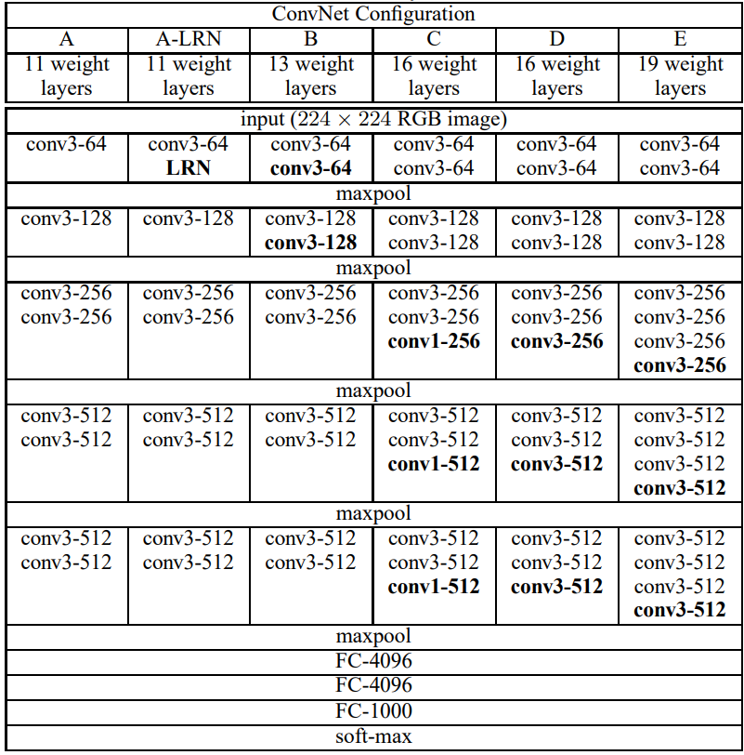
Figure 1.2 - Architecture of different versions of VGGNet CNNs.
To showcase the most common layer types found in CNN architectures, let us examine the most popular model from VGGNet family, namely VGG16, in detail. As shown in Fig. 1.2 under column C, VGG16 is a deep neural network comprising 23 layers organized into 6 distinct blocks. The first five blocks are convolutional blocks, each terminated by a max-pooling layer responsible for spatial downsampling. The final block is the classifier head, consisting of three fully connected (FC) layers, two with 4,096 units each, followed by a 1,000-unit output layer with a softmax activation. The output dimensionality of 1,000 corresponds directly to the number of classes in the ImageNet-1K dataset, on which VGG16 was originally trained. Convolutional layers serve as the primary computational workhorse of the entire architecture. Unlike fully connected layers, which process the entire input globally by connecting every input neuron to every output neuron, convolutional layers operate locally by processing only a small spatial window of M × N pixels at a time, defined by the kernel size. This operation, known as point-wise convolution, is expressed as:
(1.1)
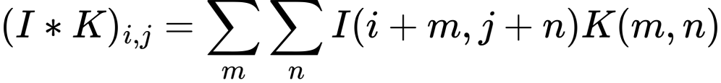
where I denotes the input image on which the convolution is performed, K denotes the learnable kernel, (i, j) represents the 2D coordinates of the output pixel, and (m, n) represents the 2D coordinates within the kernel window.
The kernel is "slid" systematically across the input with a defined stride, computing a weighted sum at each position and producing a feature map as output. Because each neuron in a convolutional layer responds only to its local receptive field rather than the entire image, the model is constrained to learn local spatial patterns, such as edges, textures and shapes, independent of their absolute position within the image. This property, known as translational invariance, represents a fundamental advantage over earlier perceptron-based models, which had no such spatial awareness.
Finally, the fully connected layers at the end of the network consume the flattened output of all preceding convolutional blocks simultaneously, treating the entire extracted feature representation as a single global vector. Each FC layer applies a learned linear transformation to this vector, producing a set of raw unnormalized scores known as logits - one per output class - which can be interpreted as the model's internal confidence that the input image belongs to each respective category.
These logits are subsequently passed through a softmax function, defined as:
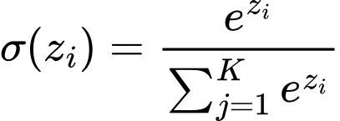
(1.2)
where z denotes the vector of raw logits and K is the total number of output classes. The softmax transformation maps the logits to a proper probability distribution, ensuring that all output values lie in the range (0, 1) and sum to exactly 1. This allows the model's output to be directly interpreted as class membership probabilities.
The final classification decision can then be derived from this probability distribution using several strategies. The simplest approach is argmax selection, which chooses the class with the highest assigned probability as the model's prediction. Alternatively, the top-N method can be employed, where the N classes with the highest probabilities are returned as candidate predictions, a scheme commonly used in evaluation benchmarks such as ImageNet, where top-5 accuracy is reported alongside top-1 accuracy.

TRANSFER LEARNING
As demonstrated by Zeiler & Fergus [18] through their DeconvNet visualization framework, convolutional layers learn to detect features of progressively increasing complexity as depth increases, from primitive low-level patterns such as edges and color gradients in the earliest layers, to mid-level structures such as textures and object parts in intermediate layers, and finally to high-level semantic representations in the deepest convolutional blocks. Crucially, this visualization work revealed that these learned feature hierarchies are not specific to any particular classification task, rather, they reflect general visual concepts that are broadly applicable across a wide range of image recognition problems.
This insight gave rise to the paradigm of transfer learning, the practice of reusing convolutional blocks from a large model pretrained on a substantial dataset, such as ImageNet, and replacing only the classifier head with a new, task-specific architecture suited to the target problem. The underlying intuition is straightforward: if a model has already learned to extract rich and general visual features from millions of diverse images, there is little justification for discarding that knowledge and retraining from scratch on a smaller, domain-specific dataset. Instead, the pretrained convolutional backbone is either fine-tuned by slightly tweaking parameter values of last N blocks or layers to better infer domain specific tasks or frozen completely and reused as is while only the newly attached classifier head is trained to map those features to the desired output classes.
This approach offers several significant practical advantages. First, it dramatically reduces the amount of labeled training data required to achieve high classification accuracy, since the backbone already captures general visual representations that would otherwise require enormous datasets to learn. Second, it substantially shortens training time, as only a fraction of the network's parameters need to be updated. Third, and perhaps most importantly, it consistently improves model performance when base model is selected for the same task it was trained for, such as using CNN trained on ImageNet-1K for image classification on smaller dataset. Pan & Yang [2] formally established the theoretical foundations of this approach, and subsequent empirical work has confirmed that selecting a relevant, domain-appropriate base model can yield significant accuracy gains over training from scratch, even when the available target dataset is relatively small.
In the context of plant disease recognition, transfer learning is especially well-motivated. The PlantVillage dataset, while substantial for an agricultural benchmark, remains orders of magnitude smaller than ImageNet. Training a deep architecture such as EfficientNet from random initialization on such a dataset would risk severe overfitting and poor generalization. By initializing the convolutional backbone with ImageNet-pretrained weights and fine-tuning only the classifier head or selectively unfreezing the uppermost convolutional blocks the model benefits from a rich prior over visual features, enabling it to converge faster and generalize more reliably to unseen leaf images.

PLANT DISEASE DATASETS

PLANTVILLAGE
The foundation upon which the majority of deep learning research in plant disease recognition rests is the PlantVillage dataset, introduced by Hughes & Salathé [11] as an open-access repository of expertly curated leaf images hosted on the PlantVillage online platform. The authors recognized that a critical bottleneck in developing automated diagnostic tools was the absence of any large, freely available, verified image dataset for plant health. To address this gap, images were collected at experimental research stations associated with Land Grant Universities across the United States, photographed under controlled conditions against uniform backgrounds, and annotated by plant pathology experts. The resulting dataset contains 54,309 images organized into 38 classes spanning 14 crop species and 26 distinct diseases with images of healthy leaves added for reference. Dataset is openly accessible and released under the Creative Commons Attribution-ShareAlike 3.0 license, with the clarification that algorithms trained on the data fall under the same license. The dataset was explicitly designed as the foundation of an ongoing crowdsourcing effort, with the long-term vision of enabling smartphone-assisted disease diagnosis at a massive global scale, particularly for the smallholder farmers in the developing world who are most vulnerable to crop losses yet have the least access to expert agronomic advice.
Despite its widespread adoption and undeniable value to the research community, the PlantVillage dataset carries inherent limitations that are important to acknowledge. All images were collected under controlled laboratory conditions, with isolated single leaves placed against plain backgrounds, photographed under consistent lighting, which results in a distribution significantly different from the complex, variable conditions encountered in real agricultural fields. Models trained on PlantVillage dataset show outstanding performance in testing environments, with certain architectures [1] [6] achieving >99% accuracy. However, due to “perfect” nature of images in datatset, same models, when applied to real-world images, show underwhelming results, with CNN achieving ~31% accuracy [6] and ViT-MoE achieving 74% accuracy [1]. Furthermore, Noyan [20] identified label-correlated background biases in the dataset, showing that a model trained purely on background pixels could achieve well above random-chance accuracy, a finding that raises concerns about whether models are genuinely learning disease-relevant leaf features or exploiting dataset-specific artifacts.
Nonetheless, PlantVillage remains the most widely used benchmark dataset in the plant disease recognition literature and will serve as the primary training and evaluation resource for the model developed in this work.
. 
Figure 1.3 - Example images from PlantVillage dataset. Left image shows apple leaf infected by apple scab. Right image shows healthy apple leaf.

PLANTDOC
Recognizing the fundamental limitations of the PlantVillage dataset researchers from India sought to construct a more ecologically valid benchmark by compiling PlantDoc, a dataset explicitly designed to reflect the visual complexity of real-world agricultural environments [19]. Rather than collecting images under controlled conditions, the team curated their dataset by carefully scraping images from the internet and spent over 300 hours manually labeling them with the assistance of plant pathology experts. The resulting dataset comprises 2,598 images spanning 13 plant species and 17 disease classes, capturing the natural variability of field conditions, including inconsistent lighting, cluttered backgrounds, partial occlusions, and varying camera angles, that are entirely absent from PlantVillage.
For the purposes of this work, PlantDoc serves a specific and important role: rather than being used for training, it is employed exclusively as an independent validation benchmark. This experimental design, training on PlantVillage and evaluating on PlantDoc, allows for a principled assessment of the proposed model's ability to generalize beyond the controlled conditions of its training distribution, providing a more honest estimate of real-world deployment performance than in-distribution testing alone could offer.
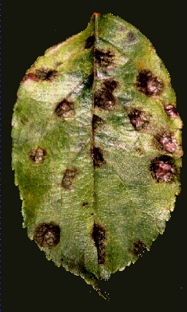
Figure 2.4 - Example images from PlantDoc dataset. Left image shows apple leaf infected by apple scab. Right image shows healthy apple leaf.

EXISTING PLANT DISEASE CLASSIFICATION MODELS

MOHANTY ET AL. [6]
One of the earliest and most influential demonstrations of deep learning applied to plant disease recognition was presented by Mohanty, Hughes & Salathé in 2016 [18]. Motivated by the lack of scalable diagnostic infrastructure in developing regions, where over 80% of agricultural production comes from smallholder farmers particularly vulnerable to crop losses, the authors framed automated image-based disease detection as both a technical and humanitarian challenge. Using the PlantVillage dataset, they systematically evaluated two best CNN architectures available at the time, massive AlexNet and smaller GoogLeNet, under multiple experimental configurations, including training from scratch versus transfer learning, and three image representations: color, grayscale, and background-segmented. Their best-performing configuration, GoogLeNet with transfer learning on color images using an 80/20 train-test split, achieved an overall accuracy of 99.34% and a mean F1 score of 0.9934 on the held-out PlantVillage test set. Notably, the authors also assessed real-world generalization by testing the trained model against 121 images sourced from agricultural extension services online, images captured under entirely different conditions from the training data. In this setting, top-1 accuracy dropped sharply to 31.4% and top-5 accuracy reached only 52.89%. The authors candidly acknowledged that a more diverse set of training data would be required to bridge this gap between controlled laboratory conditions and practical field deployment, a limitation that remains an active area of research to this day.
It is worth noting that this study was published in 2016, at a time when AlexNet and GoogLeNet represented the state of the art in CNN architecture design. Both architectures have since been substantially superseded by more efficient and accurate models. In particular, EfficientNet [4] and its enhanced version EfficientNetV2 [5], which employs compound scaling to simultaneously optimize network depth, width, and resolution, has been shown to outperform both AlexNet and GoogLeNet on ImageNet by a significant margin while requiring considerably fewer parameters. Given that Mohanty et al. demonstrated strong results even with these older architectures, this work aims to utilize EfficientNetV2 as the backbone for transfer learned model, which, hopefully, will show better results then those achieved by AlexNet and GoogLeNet.

SALMAN ET AL. [1]
A more recent and notably more ambitious approach to plant disease classification was presented by Salman, Muhammad & Han (2025), who addressed one of the most persistent challenges in the field: the sharp performance degradation that occurs when models trained on controlled laboratory datasets are deployed in real-world agricultural environments. Rather than relying on CNN-based architectures, the authors proposed a novel framework combining a Vision Transformer (ViT) backbone with a Mixture of Experts (MoE) module, a gating-based architecture in which multiple specialized sub-networks, each trained to handle different aspects of the input data, are dynamically selected for each incoming image. To further improve robustness, the model incorporates both entropy regularization and orthogonal regularization, which discourage expert collapse and ensure balanced utilization of the specialist classifiers. Evaluated on the PlantVillage dataset, the model demonstrated 68% accuracy when applied to PlantDoc dataset surpassing strong CNN baselines on this benchmark. This represents a meaningful improvement over the 31.4% real-world accuracy reported by Mohanty et al. (2016), underscoring how far the field has progressed in bridging the lab-to-field generalization gap.
However, the architectural complexity of the ViT-MoE framework comes at a significant computational cost. Vision Transformers, by design, treat the input image as a sequence of flattened patches and compute full pairwise self-attention across all patches simultaneously, a process whose memory and computational requirements scale quadratically with image resolution. Unlike CNNs, ViTs lack the inductive biases of locality and translational invariance, which means they require substantially more data and computation to converge, and the resulting models are considerably larger and slower at inference time. While this may be acceptable in high-resource research settings or offline batch processing scenarios, it presents a fundamental obstacle for deployment in lightweight, real-time systems, such as a web-based plant disease prediction tool, that this work aims to create, accessible to farmers on standard hardware or mobile devices. For such applications, an architecture that balances strong classification accuracy with computational efficiency is far more appropriate. EfficientNetV2, with its compound scaling strategy and significantly lower parameter count, offers precisely this trade-off, making it a more suitable backbone for the system proposed in this work.

Ⅲ. SYSTEM DESIGN

GOALS AND OBJECTIVES
The primary aim of this work is to develop a web-based system that provides users worldwide with accessible, easy-to-use tooling for automated classification of plant diseases using a neural network. To achieve this, the following core objectives have been identified:
1. Open Source - All components of the system, including model weights, source code, training pipelines, and user documentation, shall be made fully open source. This ensures that any individual, researcher, or organization worldwide can deploy the system independently, adapt it to their specific needs, and contribute improvements back to the community. This objective is particularly important in the context of smallholder farming communities in developing regions, where access to proprietary commercial solutions is often economically infeasible.
2. Speed and Efficiency - Computational efficiency is a primary design consideration. While the system is not intended for extreme edge deployment such as embedded microcontrollers, it must remain practical for users and organizations without access to high-end hardware infrastructure. This constraint directly motivates the choice of a lightweight CNN-based architecture over more computationally demanding alternatives such as Vision Transformers, which, despite latter strong performance, impose prohibitive resource requirements for inference and training.
3. Ease of Use for End Users - The user interface shall be intuitive, uncluttered, and accessible to users with varying levels of digital literacy. The system should require no specialized knowledge to operate. A user should be able to upload a leaf image and receive a meaningful diagnostic result with minimal friction.
4. Ease of Use for Developers - The system architecture shall be designed with deployability and maintainability in mind, enabling other developers to run, modify, and extend the system with minimal overhead. Clear documentation and a modular codebase are considered first-class requirements alongside functional correctness.
5. Security and Reliability - As a publicly accessible web-facing system, the application must be reasonably protected against threats inherent to the web environment. Stability and graceful handling of unexpected inputs are considered essential properties for a system intended for broad public use.
The development of this system is subject to the following key challenges:
1. Generalization - As discussed in the literature review, models trained on controlled benchmark datasets such as PlantVillage consistently exhibit a significant drop in performance when evaluated against real-world field images. Bridging this domain gap represents the most fundamental technical challenge of this work. Furthermore, given that no currently available model achieves reliable real-world accuracy, the system shall present the user with multiple candidate predictions rather than a single classification result, in order to not misguide user by providing invalid information.
2. Training Data Quality - Both PlantVillage and PlantDoc, while invaluable resources, carry inherent limitations, including controlled acquisition conditions, class imbalance, and dataset-specific biases, that are likely to affect the generalization capability of any model trained on them. These limitations must be carefully considered during the training process.
3. Web Deployment Constraints - Serving a trained deep learning model within a web environment introduces a distinct set of technical challenges separate from model training, including model serialization, inference latency, and memory management under concurrent user load. These constraints impose additional requirements on the choice of architecture and the design of the serving infrastructure.

WEB MODULE

SYSTEM FUNCTIONS
To address the objectives presented in the Goals and Objectives chapter, the web system must be capable of performing the following functions:
1. Disease Classification - For the purposes of executing its primary function, the system must accept a valid image file submitted by the user and return the top-5 most likely disease classification candidates along with their associated confidence scores. This multi-candidate output strategy acknowledges the inherent uncertainty of real-world plant disease recognition and provides more actionable diagnostic information than a single hard prediction.
2. File Validation - Prior to passing any uploaded file to the classification model, the system must validate that the submitted file is a genuine image of an accepted format and does not exceed a defined size threshold. Files failing validation must be rejected with a clear, informative error message. This function serves both as a reliability safeguard and as a basic security measure against malicious or malformed file uploads.
3. Result Presentation - The system must present classification results to the user in a clear, human-readable format. Confidence scores must be displayed alongside each candidate prediction in a manner that is interpretable by users without a machine learning background.
4. Error Handling - The system must handle failure conditions gracefully and transparently. In the event of an invalid input, a failed inference, or service unavailability, the user must receive a meaningful and actionable error message rather than a raw technical error or silent failure.
5. Responsive User Interface - The user interface must be fully functional and visually coherent across a range of devices and screen sizes, including desktop browsers and mobile devices. Given that a significant portion of the target user base in agricultural and developing-world contexts accesses the internet primarily via smartphone, mobile compatibility is considered a first-class requirement.
6. Rate Limiting - For the purposes of maintaining system stability and balancing server-wide load, the system must implement request rate limiting at the server level, capping the total number of requests processed within a given time window regardless of their origin. This prevents resource exhaustion under high concurrent load and ensures consistent availability for all users.
7. Configurability - For the purposes of maintainability and flexible deployment, the system must expose all operationally significant parameters, such as rate limiting thresholds, maximum file upload size, accepted file formats, server port, and other runtime values, through a centralized configuration interface. This allows the system to be adapted to different deployment environments and hardware constraints without requiring code changes or redeployment, and ensures that developers running the system for their own purposes can tune its behaviour to their specific needs.

SYNTHESIS OF STRUCTURE - FRONTEND
To implement functions mentioned in System Functions chapter, the following structure of the frontend is proposed.
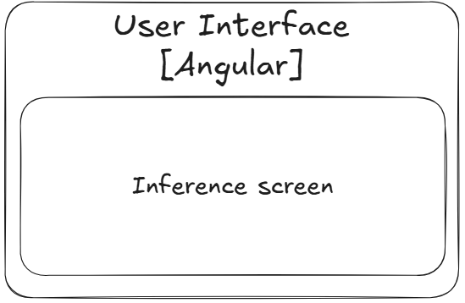
Figure 3.1 - Front end module container diagram
The frontend module serves as a straightforward and focused interface for the system's primary purpose, submitting plant leaf images for disease classification and presenting the resulting predictions to the user. In keeping with the ease-of-use objective established in the Goals and Objectives chapter, the user interface is intentionally minimal, exposing only the functionality necessary to fulfil the system's core function without unnecessary complexity.
To this end, the frontend consists of a single module:
Inference Screen - Upon navigating to the root page of the application, whether from a desktop browser or a mobile device, the user is greeted with the inference screen, which serves as the sole point of interaction with the system. The layout is fully responsive, adapting gracefully to a wide range of screen sizes and orientations to ensure a consistent experience across device types.
From this screen, the user may upload an image of a plant leaf they wish to analyze. Prior to submission, the interface validates that the selected file meets the required format and size constraints, providing immediate and informative feedback should the file be deemed invalid, preventing unnecessary round trips to the server and reducing user confusion. Upon submitting a valid image, a loading indicator is displayed for the duration of the server-side inference process, communicating to the user that their request is being processed and preventing the perception of an unresponsive interface.
Once the server returns a response, the inference results are presented directly on the same screen in a clear, human-readable format, displaying the top-5 most likely disease classifications alongside their respective confidence scores in a manner interpretable by users without a machine learning background. To comply with Error Handling system function, should the server return an error, whether due to a processing failure, service unavailability, or any other unexpected condition, the screen displays a meaningful and actionable error message in place of the results, ensuring the user is never left without feedback.
The frontend module is implemented using Angular as the framework of choice. Angular's opinionated, component-based architecture enforces a clear separation of concerns and provides a well-defined project structure out of the box, significantly reducing the overhead associated with architectural decision-making during development. Its wide and mature ecosystem offers convenient, well-maintained solutions for common frontend requirements, including reactive forms, HTTP client integration, and responsive layout tooling, many of which are directly applicable to the needs of this system. Additionally, prior familiarity with the framework on the part of the developer of this project allows development effort to be directed toward solving domain-specific problems rather than navigating an unfamiliar toolchain..

SYNTHESIS OF STRUCTURE - BACKEND
To implement functions mentioned in System Functions chapter, the following structure of the backend is proposed.
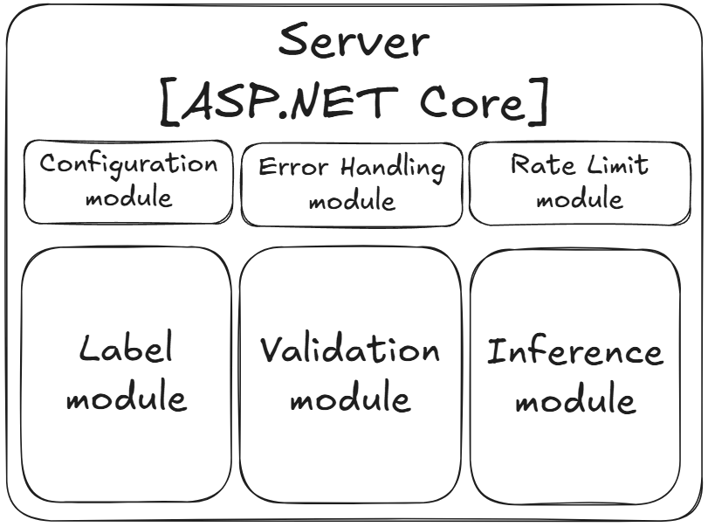
Figure 3.2 - Backend module container diagram
The backend module serves as the intermediary layer between the frontend and engine modules, acting as the primary gatekeeper responsible for controlling access, validating incoming data, and coordinating communication between system components. It is implemented using ASP.NET Core with a controller-based architecture, exposing a defined set of API endpoints through which the frontend communicates with the rest of the system. The backend consists of the following modules:
1. Configuration Module - The configuration module is responsible for loading and exposing all operationally significant runtime parameters required by the backend and ASP.NET Core itself, including rate limiting thresholds, file size limits, and accepted file formats. All configurable values are sourced from a centralized configuration interface, ensuring that the system can be adapted to different deployment environments without requiring code changes.
2. Rate Limiting Module - The rate limiting module is responsible for enforcing a server-wide cap on the number of requests processed within a given time window, with the maximum threshold defined by the configuration module. Requests exceeding this limit are rejected before reaching any downstream processing logic, protecting the system from resource exhaustion under high concurrent load and ensuring consistent availability for all users.
3. Validation Module - The validation module is responsible for confirming the integrity and acceptability of data submitted by the frontend before it is passed to any downstream module. This includes verifying that uploaded files are of an accepted format and do not exceed the configured size threshold. Any request failing validation is rejected at this stage with a clear and informative error response, preventing malformed or potentially malicious data from reaching the inference pipeline.
4. Inference Module - The inference module is responsible for accepting validated image data from the frontend and forwarding it to the external engine module for processing. Upon receiving the engine's response, the module returns resulting classifications along with their associated confidence scores to the frontend for presentation to the user.
5. Label Module - The label module is responsible for retrieving the complete set of classification labels from the engine module on application startup.
6. Error Handling Module - The error handling module acts as a global exception handler, intercepting any unhandled errors that propagate through the request pipeline before they reach the frontend. Rather than exposing raw stack traces or cryptic HTTP error codes, the module ensures that all failure conditions are translated into consistent, meaningful, and user-appropriate error responses, maintaining a predictable API contract regardless of the nature of the underlying failure.

SYNTHESIS OF STRUCTURE- ENGINE
To implement functions mentioned in System Functions chapter, the following structure of the engine is proposed.
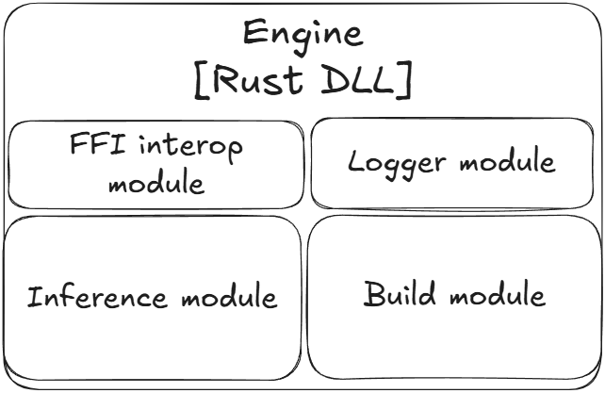
Figure 3.3 - Engine module container diagram
The engine module serves as the primary execution environment for model inference. It is implemented in Rust using the Burn deep learning library and compiled into a dynamic-link library (DLL) that is loaded directly by the backend module at runtime. This architecture isolates the computationally intensive inference logic from the backend, allowing each component to be developed, tested, and updated independently. A key architectural property of the engine is that it is entirely self-contained, both the model weights and metadata are baked directly into the compiled DLL binary at compile time, meaning no external files are required at runtime.
The engine consists of the following modules:
1. Build Module - The build module operates exclusively at compile time via Burn's build pipeline and is responsible for transforming external source model artifacts into native Rust representations that are embedded directly into the binary. Specifically, the module ingests the model in ONNX format and transforms it into a generated Rust file representing the network architecture and weights as a native Burn model struct. In parallel, a metadata.json file containing model metadata, including class labels and input size is parsed and transformed into a generated metadata.rs file representing the metadata as a native Rust struct. Both generated files are incorporated into the binary at compile time via Rust's include! macro, ensuring that the final compiled DLL requires no external files to be present at runtime.
2. FFI Interop Module - The FFI interop module is responsible for exposing the engine's functionality across the language boundary between Rust and C#. It implements the set of extern "C" functions required for cross-language interoperability, providing the backend module with a stable, well-defined C-compatible interface through which it can invoke inference, retrieve labels, and initialize the engine without any knowledge of Rust's internal type system or memory model.
3. Logger Module - Since the engine operates as a DLL loaded into the ASP.NET Core process, its internal logging must be integrated into the host application's logging pipeline rather than operating independently. The logger module is responsible for implementing a custom Rust logging backend that forwards log messages emitted by the engine to ASP.NET Core's logging infrastructure, ensuring that engine-side events — including errors, warnings, and diagnostic information — are captured and surfaced consistently alongside backend logs.
4. Inference Module - The inference module is the core computational component of the engine, responsible for accepting raw image bytes forwarded from the backend via the FFI interop module and executing the classification pipeline. This includes decoding the raw bytes into a tensor representation, applying the necessary preprocessing transformations, running a forward pass through the embedded Burn model, and returning the resulting output logits to the backend for further processing into top-5 classification candidates.
5. Metadata Module - The metadata module is responsible for exposing the model metadata embedded at compile time — including the full set of classification labels, model name, and version information — to the backend via the FFI interop module. Since metadata is static for the lifetime of the application, it is read directly from the embedded metadata.rs struct and returned on demand without any runtime file access or additional processing overhead.

MODEL TRAINING

ASSESSMENT OF DATASETS
For training, two datasets are utilized: PlantVillage and PlantDoc. As discussed in the previous chapter, PlantDoc will be used exclusively as an independent validation benchmark and will not be included in the training loop itself, serving as a measure of the model's ability to generalize beyond the controlled conditions of its training distribution.
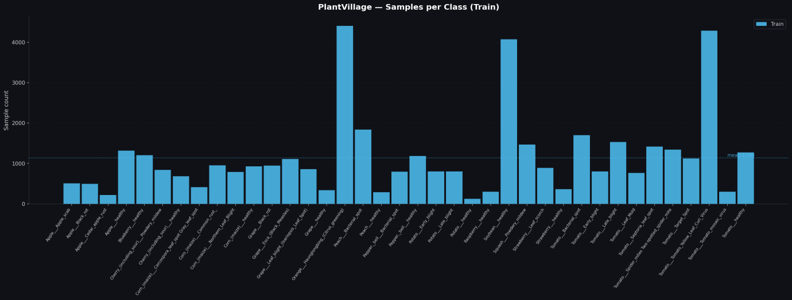
Figure 3.4 - Number of train samples for every class in PlantVillage dataset
As evident from Fig. 3.4, the PlantVillage training set is notably unbalanced, while the majority of classes cluster around a mean of approximately 1,200 samples, a small number of classes are significantly overrepresented, exceeding 4,000 samples, while others fall as low as 200. To investigate the effect of this imbalance on model performance, data augmentation strategy is treated as one of the experimental hyperparameters, with three distinct variants evaluated.
The first variant establishes a baseline by training the model on the raw PlantVillage dataset without any augmentation applied, allowing the effect of class imbalance to be observed in isolation. The second variant applies TrivialAugment [3] uniformly across all classes during training, a parameter-free augmentation strategy that randomly selects and applies a single augmentation operation at a randomly sampled intensity per training image, without requiring any manual tuning of augmentation hyperparameters. The third variant extends this approach by additionally oversampling underrepresented classes, specifically, any class falling below the dataset mean of approximately 1,200 samples is augmented via TrivialAugment until it reaches the mean, after which standard TrivialAugment is applied to all classes during training as usual.

MODEL SELECTION
As the backbone for the transfer learning model, EfficientNetV2 [5] is selected as the base architecture. EfficientNetV2 represents a compelling balance between classification performance and computational cost, making it well-suited for the efficiency requirements established in the Goals and Objectives chapter. Two variants are evaluated in this work: EfficientNetV2-S (~8.4B FLOPs) and EfficientNetV2-M (~24.7B FLOPs), offering a meaningful range of model capacity within practical hardware constraints.
The larger variants, EfficientNetV2-L (~56.3B FLOPs) and EfficientNetV2-XL (~94B FLOPs), are intentionally excluded from the experiment matrix. Given the scale of the PlantVillage dataset and the 38-class classification objective, the substantial increase in computational cost and training time associated with these variants is not expected to yield accuracy improvements sufficient to justify their inclusion. Their exclusion is further motivated by the hardware constraints of the training environment, and they are left as a natural direction for future work.

FINE-TUNING STRATEGY
The third and final experimental hyperparameter concerns the fine-tuning strategy applied to the EfficientNetV2 backbone. In the transfer learning paradigm, the pretrained backbone can be kept entirely frozen, preserving the ImageNet-learned feature representations without modification, or selectively unfrozen to allow the model to adapt its higher-level representations to the specific visual characteristics of the target domain.
Three variants are evaluated: a fully frozen backbone (N=0), in which only the classifier head is trained and all backbone weights remain fixed at their pretrained ImageNet values; partial fine-tuning with the last 1 block unfrozen (N=1), representing a conservative adaptation that allows only the most domain-specific, high-level feature extraction layers to update; and partial fine-tuning with the last 3 blocks unfrozen (N=3), allowing a broader portion of the backbone to adapt to the plant disease domain while preserving the general low-level and mid-level feature representations learned from ImageNet in the earlier stages.
This axis is motivated by the hypothesis that while ImageNet-pretrained features are broadly transferable, the highest-level convolutional representations, which encode the most task-specific semantic concepts, may benefit from adaptation to the visual characteristics of diseased plant leaves, potentially improving the model's ability to generalize across the domain gap between PlantVillage's controlled conditions and real-world field images.

SOURCES
- Plant disease classification in the wild using vision transformers and mixture of experts. URL: https://pmc.ncbi.nlm.nih.gov/articles/PMC12213485/
- A Comprehensive Survey on Transfer Learning. URL: https://arxiv.org/pdf/1911.02685
- TrivialAugment: Tuning-free Yet State-of-the-Art Data Augmentation. URL: https://arxiv.org/abs/2103.10158
- EfficientNet: Rethinking Model Scaling for Convolutional Neural Networks. URL: https://arxiv.org/abs/1905.11946
- EfficientNetV2: Smaller Models and Faster Training. URL: https://arxiv.org/pdf/2104.00298
- Using Deep Learning for Image-Based Plant Disease Detection. URL: https://pmc.ncbi.nlm.nih.gov/articles/PMC5032846/
- World Population Prospects 2024, UN. URL: https://population.un.org/wpp/
- Climate change, plant diseases and food security: an overview. URL: https://bsppjournals.onlinelibrary.wiley.com/doi/10.1111/j.1365-3059.2010.02411.x
- A meta-analysis of projected global food demand and population at risk of hunger for the period 2010-2050. URL: https://pubmed.ncbi.nlm.nih.gov/37117684/
- Climate change impacts on plant pathogens, food security and paths forward. URL: https://www.researchgate.net/publication/370466657_Climate_change_impacts_on_plant_pathogens_food_security_and_paths_forward
- An open access repository of images on plant health to enable the development of mobile disease diagnostics. URL: https://arxiv.org/abs/1511.08060
- A logical calculus of the ideas immanent in nervous activity. URL: https://link.springer.com/article/10.1007/BF02478259
- The perceptron: A probabilistic model for information storage and organization in the brain. URL: https://doi.org/10.1037/h0042519
- Perceptrons: An Introduction to Computational Geometry. URL: https://doi.org/10.7551/mitpress/11301.001.0001
- Gradient-Based Learning Applied to Document Recognition. URL: http://vision.stanford.edu/cs598_spring07/papers/Lecun98.pdf
- Backpropagation Applied to Handwritten Zip Code Recognition. URL: https://ieeexplore.ieee.org/document/6795724
- Very Deep Convolutional Networks for Large-Scale Image Recognition. URL: https://arxiv.org/abs/1409.1556
- Visualizing and Understanding Convolutional Networks. URL: https://arxiv.org/abs/1311.2901
- PlantDoc: A Dataset for Visual Plant Disease Detection. URL: https://arxiv.org/abs/1911.10317
- Uncovering bias in the PlantVillage dataset. URL: https://arxiv.org/abs/2206.04374
- Deep Residual Learning for Image Recognition. URL: https://arxiv.org/abs/1512.03385
- MobileNets: Efficient Convolutional Neural Networks for Mobile Vision Applications. URL: https://arxiv.org/abs/1704.04861

